|  |  |  |  |
| --- | --- | --- | --- |
| **Quiz#1-C** | | | |
| **Topic:** | Module 1: Descriptive Statistics: Notation | **Week No.** |  |
| **Course Code:** | ITEP 203 | **Term:** | 1st Semester |
| **Course Title:** | Quantitative Method including Modeling and Simulation | **Academic Year:** | 2021-2022 |
| **Student Name** |  | **Section** |  |
| **Due date** |  | **Points** | **25** |

This learning activity will help attain the intended learning outcomes of this module and will solidify the objectives of the module.

**Example Dataset**

An example of the data we might have collected in the topic Random Variables:

|  |  |  |  |
| --- | --- | --- | --- |
| Date | Day of Week | Time Spent On Site (x) | Buy (y) |
| June 15 | Thursday | 5 | No |
| June 15 | Thursday | 10 | Yes |
| June 16 | Friday | 20 | Yes |

Direction: Encircle the correct answers of the folowing:

**Variable Type**

1. What type of variable is the random variable X in the video in the previous concept?
2. Categorical – Ordinal
3. Categorical – Nominal
4. Quantitative – Continuous
5. Quantitative – Discrete

**Data Types 2**

1. What type of variable is the random variable Y in the video in the previous concept?
2. Categorical – Ordinal
3. Categorical – Nominal
4. Quantitative – Continuous
5. Quantitative – Discrete

Consider we have the following table:

|  |  |  |
| --- | --- | --- |
| Years Experience | Department | Part/Full Time |
| 5 | IT | Part Time |
| 10 | Finance | Full Time |
| 8 | HR | Full Time |
| 1 | Finance | Part Time |

Consider we have the following labels:

X= years of experience

Y= Department

Z= Part/Full Time

Match the following notation to their corresponding:

A. x1

B. y2

C. z3

D. n

**Notation II**

1. **QUIZ QUESTION::**Use the information above to match the correct notation label to its corresponding value. Encircle the notation (that refers to the letter with the corresponding notation above).
   1. Finance
   2. 4
   3. 16
   4. Years Experience
   5. Department
   6. Part Time
   7. 5
   8. Full Time

**Match The Notation**

For this quiz, you will be matching the notation attached the letters below to the corresponding numeric value to make sure you understand exactly what is being done with each part of the notation.

Imagine, we have the following table of values:

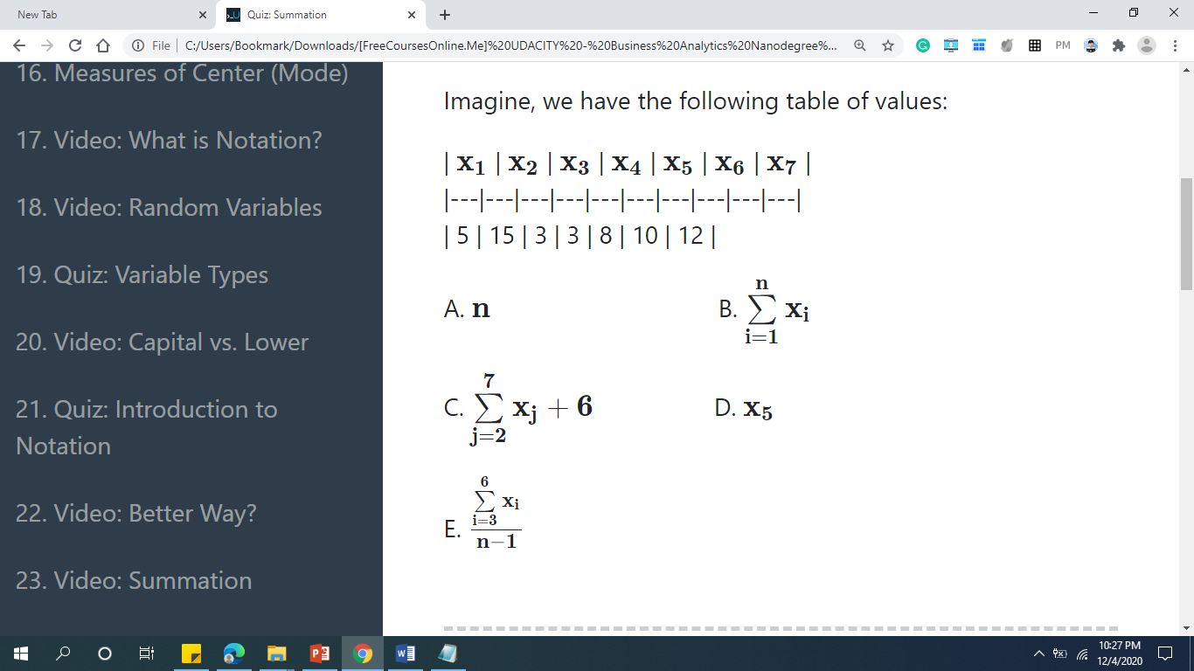

1. **QUIZ QUESTION::**Use the letters, numbers, and notation as defined above to match each letter to the appropriate value. (5 pts)

|  |  |
| --- | --- |
| **Letter** | **Value** |
| 56 |  |
| 8 |  |
| 57 |  |
| 7 |  |
| 15 |  |
| 39 |  |
| 4 |  |

**Notation for Quizzes**

For the below quiz, let the following letters denote the corresponding notation:

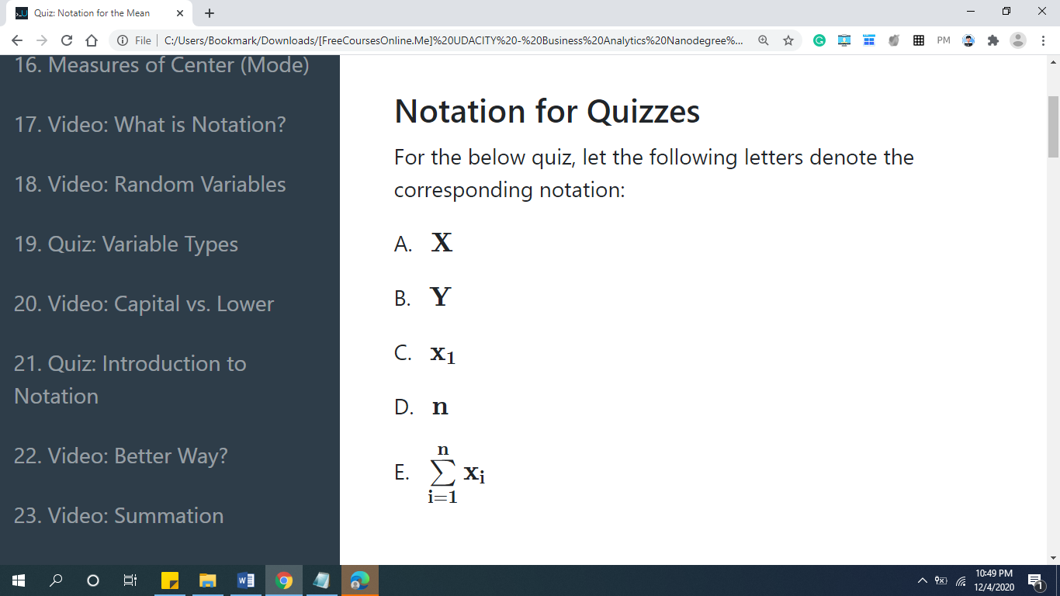

**Notation II - Question 1**

1. **QUIZ QUESTION::**Use the letter next to the notation above to match the notation to the description of what the notation represents.

|  |  |
| --- | --- |
| **Notation Letter** | **Description** |
| The notation for the number of rows in our dataset. |  |
| The notation for all of the values in our dataset. |  |
| The notation for the sum of all the values in our dataset. |  |
| The notation for a random variable. |  |
| The notation for the number of columns in our dataset. |  |
| The notation for a random variable. |  |
| The notation for all of the values in our dataset. |  |
| The notation for the first observed value of a random variable. |  |

**Reminders:**

1. AVOID PLAGIARISM, include the source/reference of the performance task output.
2. Save your quiz as **M2Q2C**-[Section]-[Surname] e.g. **M2Q2C-2F-BERNARDINO**